Meeting Minutes
https://washington.zoom.us/j/5100844374 MEET HERE

Agenda
Time | Item | Facilitator
12-12:20 | Welcome back everyone!  - Assign scribe for today  - Meet new faces  - Welcome Azaan and Julia!  - Recap from summer | Sohara
12:20-12:30 | Update on Administrative Changes  - Bylaw changes (approved by Interim Committee)  - Timeline for ASUW Representatives  - Grants Timeline  - LOIs due January 3, 2024. Full Proposal due on February 15, 2024.  - Staff changes in the office  - 2 new people joining the UWS office (policy and student engagement)  - CSF Program Director Role is open (Req #228843) | Tatiana
12:30-12:35 | WOHESC  - Who would like to join? (presenting vs. attending)  - Azaan, Lauren (present), Neha (present), Emmy, Sohara (maybe –finals), Boe, Kort,  - Early bird registration ends tomorrow | Tatiana
12:35-12:50 | Stipends for this year  - How do we want to do it?  - $1320 per year ($440 per quarter)  - Starting at end of Fall (missing 20 hrs, ~2hrs/week) | Tatiana
12:50-1:05 | Subcommittees  - Teach-In (Collaborative effort with ICA)  - Other suggested tasks: google doc | Sohara
1:05-1:20 | Vice Chair Election  - Nominations  - Speeches  - Voting (congratulations Neha!!) | Sohara / Tatiana
1:20-1:28 | Orientation Package (new members)  - What should we add?  - What would you have liked? | Sohara
1:28-1:30 | Final thoughts & adjourn | Sohara

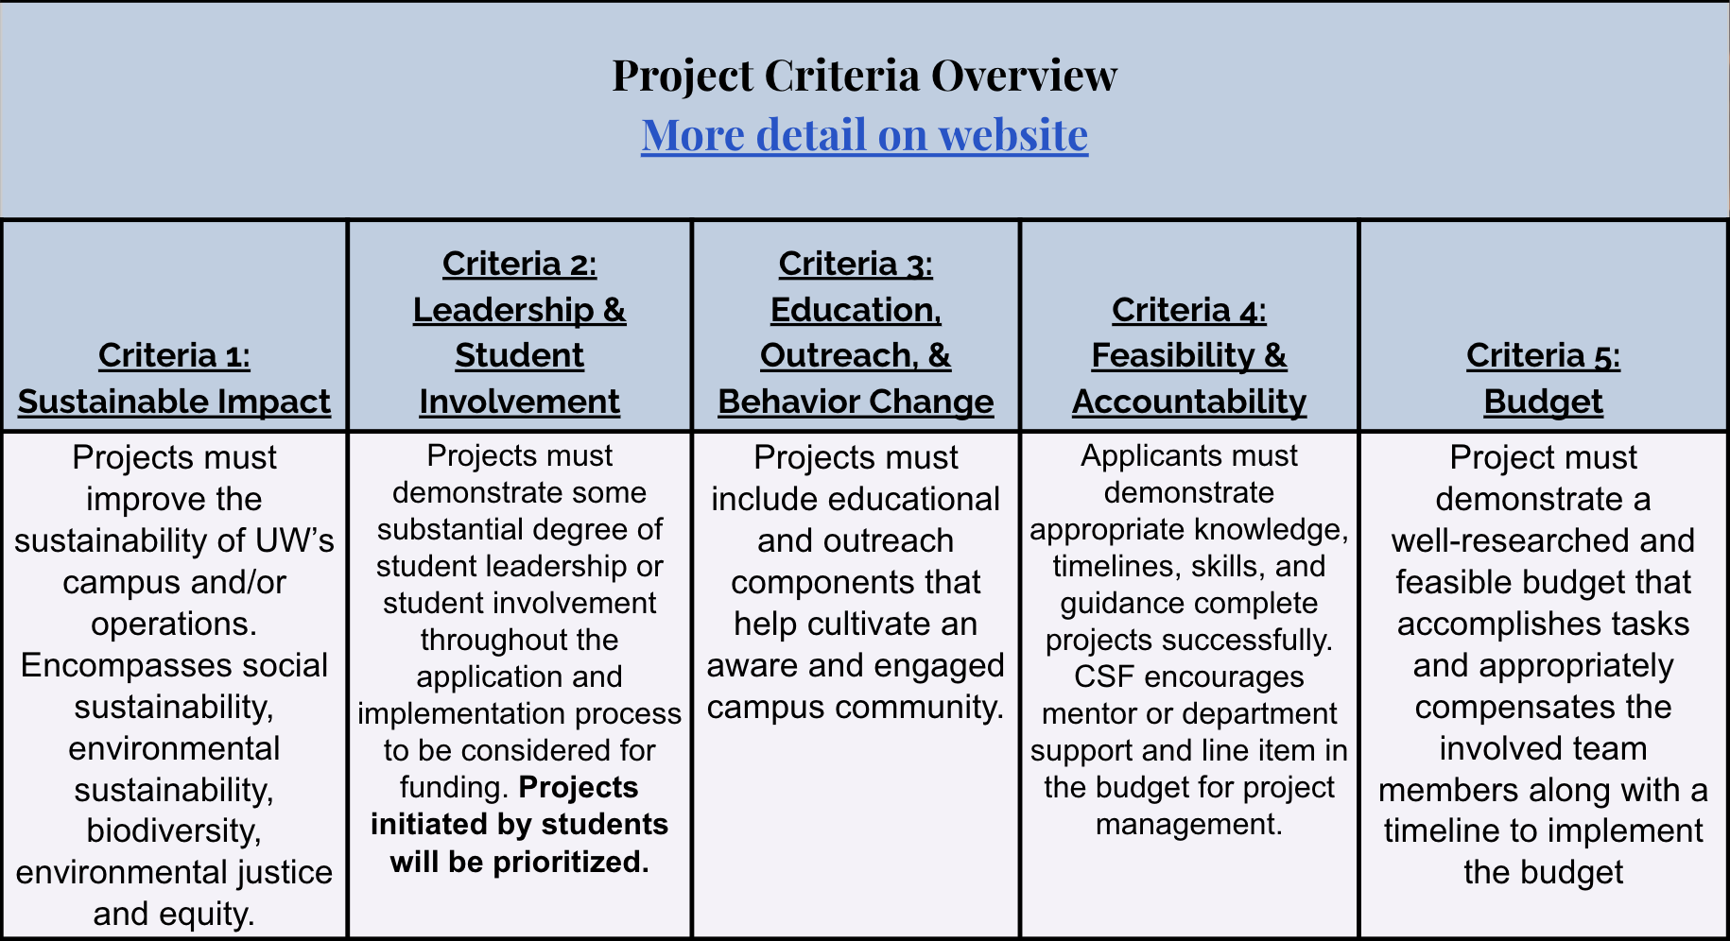

https://csf.uw.edu/how-apply/funding-guidelines

Non Allowable Uses:
- Funding cannot be used for time and labor expended by UW faculty working unless it is outside the scope of regular faculty duties.
- Funding cannot be used for the purchase of gift cards or other forms of compensation to research subjects. While we encourage compensating research subjects for their time, this must come from another funding source.
- In general, funds cannot be used for food, drinks, or salable merchandise as part of project budgets. Some exceptions may be granted.
- Line-item requests for travel funding are not encouraged, but will be considered on a case by case basis.
- Funds shall not be used for research projects unless such projects include an actionable component.

CSF Bylaws + Protocols
Committee Bylaws
Robert’s Rules of Order
Liberating Structures
CSF Committee Google Drive
2023-2024 Committee Documents
Orientation Folder

How to evaluate projects
CSF Project Criteria
Reference Sheets
Evaluation Rubric Example (go to Rubric Template tab)

Current projects + timeline
Workday Orientation - https://tinyurl.com/csf-workday
2023-2024 Proposal Deadlines & Timeline
CSF Resource Guide

Meeting Notes
In attendance:
- Sohara Mehroze Shachi
- Tatiana Brown
- Julia Indivero
- Azaan Brown
- Tava Kairaiuak
- Neha Chinwalla
- Emelyn Sung
- Lauren Cortez French
- Boe Zhou
- Danyal Lotfi

- Introductions (all attendees)
- Bylaw Updates (Tatiana):
- Interim committee serving until now
- Updates to Bylaws to reflect committee composition – passed unanimously by interim committee
  - 3 primary changes: (1) Redefined the simple majority as 5-3; (2) 8 voting members, increased from 7; (3) Clearly defining term limits
- ASUW (Azaan):
- 8 applicants thus far – currently in interview process and will notify the 2 chosen applicants soon
- Grant updates (Boe):
- Grant proposal process opened, first batch will be reviewed in winter quarter (both large grants and mini grants)
- Staff changes (Tatiana):
- New staff in Sustainability office – new staff member working on sustainability-related policy and new staff member on engagement
- Position is now open for CSF Program Director, who will be leading our team – Tatiana asked us to share with our networks
- Tatiana will be working with HR to ensure committee members’ Workday accounts will be connected to Tatiana’s
- WOHESC (Tatiana):
- We applied for two presentation opportunities and were accepted for both – poster presentation and participation on a panel
- Tatiana asked who would like to attend and that we should have enough conference funding in our budget for multiple people (attending with CSF will cover transportation (train tickets), housing, registration, and a food stipend)
- Stipends & New Potential Tasks for CSF Members (Tatiana & Sohara):
- Since we’ve gotten a late start, we’ve missed about 20 hours of this quarter’s commitments. Our options are making up those 20 hours in the spring (through various tasks discussed brainstormed in this google doc and subcommittee meetings)
- Discussed Climate Justice x Decarbonization Teach In and opportunities for participating in the planning, researching and developing content
- Another opportunity is participating in planning and strategizing for STF Funding
- Vice Chair Elections (Sohara)
- Sohara overviewed the role and responsibilities of Vice Chair and opened the floor to open nominations
- One nomination was confirmed – Neha Chinwalla
- Neha accepted her nomination and gave a speech to the group
- Voting opened via Google Form and Neha was confirmed as Vice Chair
9. Orientation Packet Discussion (Sohara & group)
- Azaan: a how-to would be great for ASUW representatives
- Julia: overview on how to review and approve grants, as well as the timeline, would be beneficial
- Lauren: overview of committee and staff members, what each of them do. If you need something (question about grants) who do you go to? Responsibilities of all team members. Having a hierarchy tree showing where sustainability is within the university. How we are connected to sustainability. Helps when explaining CSF
  - Tatiana followed up by explaining overview of where CSF is located within UW (facilities)
- Emmy: overview of Robert’s Rules would be helpful for new members
- Friendly competition: Kahoot about CSF info
- Fake project to vote on: simulation, walk you through the process
- Fun intriguing PowerPoint presentation
- Recap of all our activities last year
10. Other discussion:
- Tatiana asked Tava about where we see potential opportunities for more collaboration between UW and CSF
- Next meeting - week of Jan 8; send schedules to Neha and Sohara
- Meeting virtually vs. in-person – try to find what would work best by doing 2 different When2Meets (what would work if meeting was in-person vs. virtual)
- Before next meeting – fill out form about what we each want to do as our extra task
- Sohara: Ex-officio member list – we can add our names if we know of people of UW who might be interested
- Boe: next meeting will be a voting meeting since applications for grants will be submitted by then – will need to have new member orientation packets distributed by then

