Campus Sustainability Fund
Committee Meeting Agenda

Tuesday, February 21, 2023
6:30-7:30 pm PDT LOCATION: ZOOM

Join Zoom Meeting (2022-2023)
https://washington.zoom.us/j/5100844374
washington.zoom.us…
Agenda
Time | Item | Facilitator
6:30-6:40 | Housekeeping  - Presentation workshop tomorrow at 6 pm  - SAF Presentation  - Women’s Center – first event is this Saturday | Neha, Kyle
6:40-7:00 | Discussion on full 52nd Spring POWWOW proposal  - LOI  - Full Proposal  - Acceptance of Administrative Responsibility Form (AARF)  - Project Approval and Support Forms (PASFs)  - Supporting Documents  Rubric | Neha
7:00-7:20 | Presentation from POWWOW team | Presenters
7:20-7:30 | Final deliberations & vote  Link to vote | Neha
7:30 | Adjourn  Next time:  - Check-in with committee members | Neha

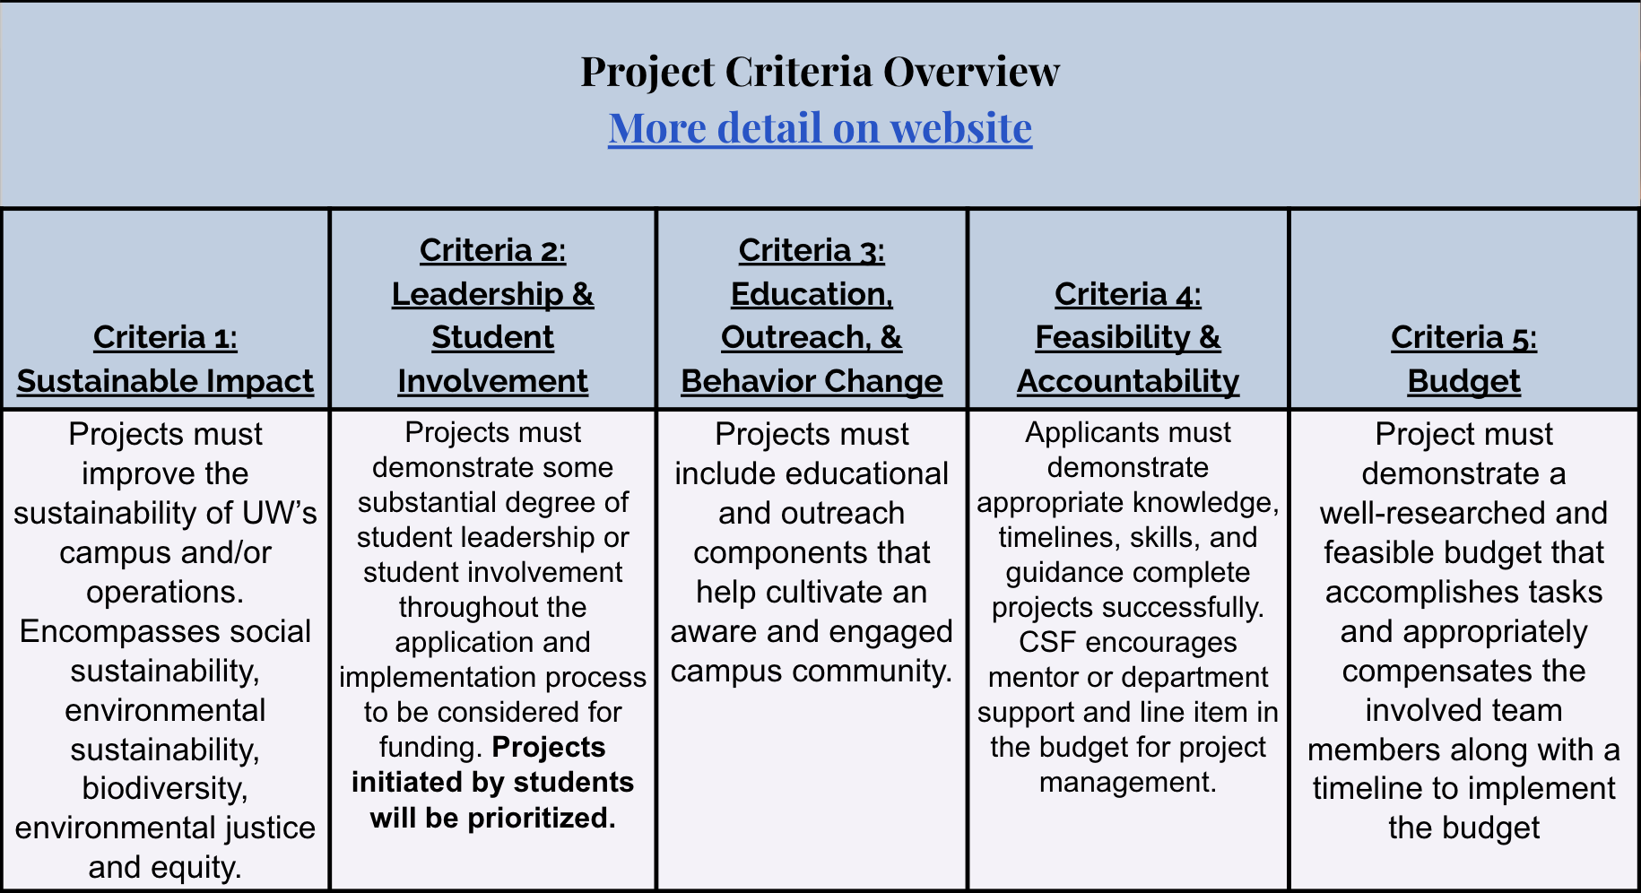

https://csf.uw.edu/how-apply/funding-guidelines

Non Allowable Uses:
- Funding cannot be used for time and labor expended by UW faculty working unless it is outside the scope of regular faculty duties.
- Funding cannot be used for the purchase of gift cards or other forms of compensation to research subjects. While we encourage compensating research subjects for their time, this must come from another funding source.
- In general, funds cannot be used for food, drinks, or salable merchandise as part of project budgets. Some exceptions may be granted.
- Line-item requests for travel funding are not encouraged, but will be considered on a case by case basis.
- Funds shall not be used for research projects unless such projects include an actionable component.

Some things for us to discuss:
- The program and position outcomes → feedback, thoughts, ideas
- Balance of adequate staffing
- Professional development opportunities

CSF Bylaws + Protocols
Committee Bylaws
Robert’s Rules of Order
Liberating Structures
CSF Committee Google Drive
2022-2023 Committee Documents

How to evaluate projects
CSF Project Criteria
Reference Sheets
Evaluation Rubric Example (go to Rubric Template tab)

Current projects + timeline
Workday Orientation - https://tinyurl.com/csf-workday
2022-2023 Proposal Deadlines & Timeline
CSF Resource Guide

CSF Committee Attendees: Neha, Esha, Lauren, Emmy, Sohara, Tava, Nat
CSF Staff Attendees: Tatiana, Kyle, Gulsima, Kort
UWS Attendees: Christoph

