Campus Sustainability Fund
Committee Meeting Agenda

Tuesday, March 14, 2023
5:30-7:00 pm PDT LOCATION: ZOOM

Join Zoom Meeting (2022-2023)
https://washington.zoom.us/j/5100844374
washington.zoom.us…
Agenda
Time | Item | Facilitator
5:30-5:35 | Check in + icebreaker: report back on presentation | Neha
5:35-5:40 | Housekeeping  - WOHESC presentation  - Women’s Center event TOMORROW  - RSVP  - Discussion and vote on 52nd Powwow Budget Amendment (passes with 5 votes to fund $6k if needed & write letter of support, CSF team+Neha+Sohara) | Tatiana, Neha
5:40-6:30 | Discussion and vote on large grant LOIs (10 mins per LOI)  - Camas Meadow at the Burke Museum (7 Yes, Pass!)  - Sustainable Stormwater Feasibility @ the ASUW Shell House (7 yes, Pass!)  - Energy, Information, and the New Work of Building Operations in the Digital Age (6 yes, Pass!)  - Friday Harbor Laboratories - Electric Vehicle Charging Stations(1 vote, fails)  Rubric  Spreadsheet  Presentation | Neha, Gulsima
6:30-7:00 | Discussion and vote on mini grants  - 2023 TSA Night Market Sustainable Program (6 yes, pass!)  - Tzu Chi Collegiate Association Veggie Fest (  - Bricolage Literary and Visual Arts Journal, Issue 41  - UW Farm Dirty Dozen DIY Vermicompost Night (7 yes, passes) | Neha, Gulsima
7:00 | Adjourn  - Have a great spring break <3 :-) | Neha

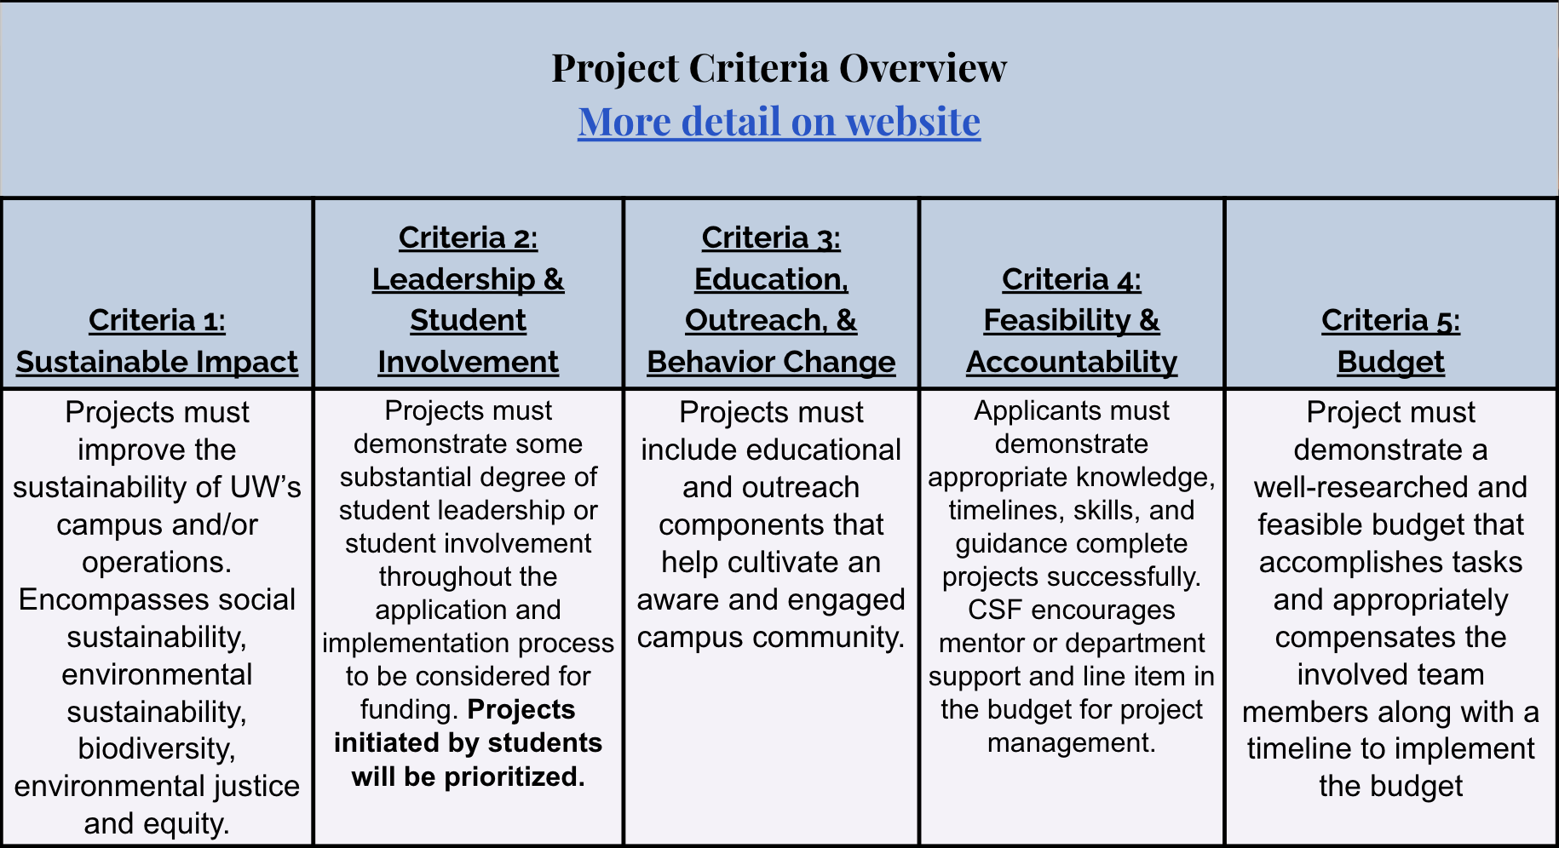

https://csf.uw.edu/how-apply/funding-guidelines

Non Allowable Uses:
- Funding cannot be used for time and labor expended by UW faculty working unless it is outside the scope of regular faculty duties.
- Funding cannot be used for the purchase of gift cards or other forms of compensation to research subjects. While we encourage compensating research subjects for their time, this must come from another funding source.
- In general, funds cannot be used for food, drinks, or salable merchandise as part of project budgets. Some exceptions may be granted.
- Line-item requests for travel funding are not encouraged, but will be considered on a case by case basis.
- Funds shall not be used for research projects unless such projects include an actionable component.

CSF Bylaws + Protocols
Committee Bylaws
Robert’s Rules of Order
Liberating Structures
CSF Committee Google Drive
2022-2023 Committee Documents

How to evaluate projects
CSF Project Criteria
Reference Sheets
Evaluation Rubric Example (go to Rubric Template tab)

Current projects + timeline
Workday Orientation - https://tinyurl.com/csf-workday
2022-2023 Proposal Deadlines & Timeline
CSF Resource Guide

CSF Committee Attendees: Neha, Lauren, Emmy, Sohara, Tava, Nat
CSF Staff Attendees: Tatiana, Kyle, Gulsima
UWS Attendees: —

