Campus Sustainability Fund
Committee Meeting Agenda

Tuesday, April 18, 2023
6-7:30 pm PDT LOCATION: ZOOM

Join Zoom Meeting (2022-2023)
https://washington.zoom.us/j/5100844374
washington.zoom.us…
Agenda
Time | Item | Facilitator
6:00-6:10 | Check in + Housekeeping  - Seed Grant Applications are LIVE, open until April 30 → spread the word  - Tzu Chi Veggie Fest: 4/29 (5-7 pm) at Mary Gates Hall | Neha
6:10-6:20 | Mini Grant Review: KERATON  Budget Amendment Review for Resilience Tunnel | Neha
6:20 | Goal Review & Check in  Guiding questions:  - How do you feel about the CSF Committee so far this year? How do you feel about your participation in the Committee so far?  - What’s working? What isn’t?  - Have you reached or made progress on your goals? How can we support you?  (miro board)  - Trying to have in-person meetings/gatherings  - Having a social  - Time constraints on engaging  - Having more opportunities to hear from project teams, engage with them live and ask them questions  - Hearing updates after events we fund happen  - Plan to attend events we fund (or other sustainability events) together  - More of an outreach aspect of what we do  - Go to RSO meetings and explain who we are and what we do, present funding opportunities so people are more aware of it  - Skill-building for careers (such as GHG accounting) → can CSF use funding for internal activities as well such as trainings/central fund to support personal/professional development goals?  - Bigger role in helping brainstorm/plan for CSF collective | Neha
Adjourn | when discussion is over 🙂 | Neha

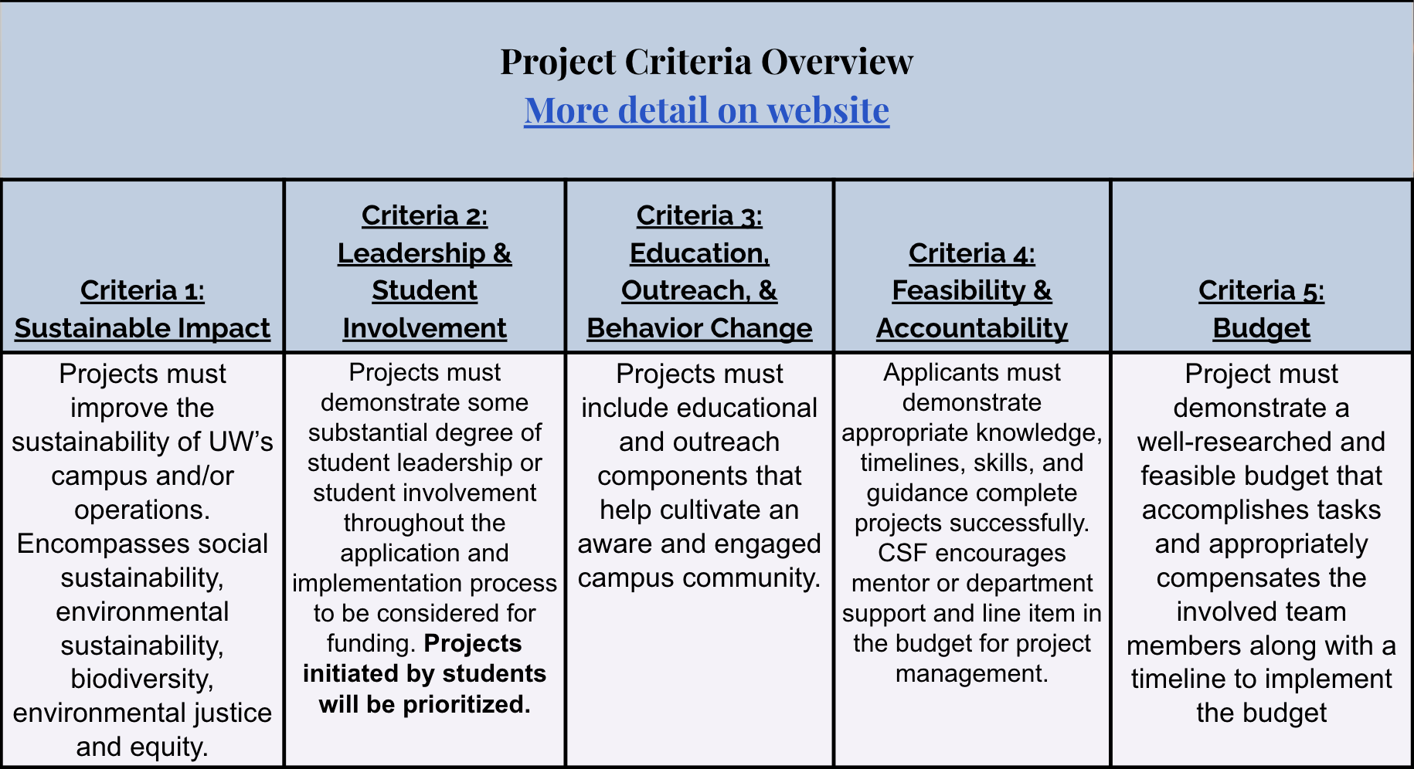

https://csf.uw.edu/how-apply/funding-guidelines

Non Allowable Uses:
- Funding cannot be used for time and labor expended by UW faculty working unless it is outside the scope of regular faculty duties.
- Funding cannot be used for the purchase of gift cards or other forms of compensation to research subjects. While we encourage compensating research subjects for their time, this must come from another funding source.
- In general, funds cannot be used for food, drinks, or salable merchandise as part of project budgets. Some exceptions may be granted.
- Line-item requests for travel funding are not encouraged, but will be considered on a case by case basis.
- Funds shall not be used for research projects unless such projects include an actionable component.

CSF Bylaws + Protocols
Committee Bylaws
Robert’s Rules of Order
Liberating Structures
CSF Committee Google Drive
2022-2023 Committee Documents

How to evaluate projects
CSF Project Criteria
Reference Sheets
Evaluation Rubric Example (go to Rubric Template tab)

Current projects + timeline
Workday Orientation - https://tinyurl.com/csf-workday
2022-2023 Proposal Deadlines & Timeline
CSF Resource Guide

CSF Committee Attendees: Neha, Lauren, Emmy, Sohara, Tava, Nat
CSF Staff Attendees:
UWS Attendees: —

