Project Approval Form (PAF)
Project Title: | Engaging Students and Public in Marine Conservation through Sustainable Shellfish Aquaculture (Phase I)
Primary Contact: | Daniel Gillon – dgillon@uw.edu

By signing this form, I confirm that the project lead(s) has/have discussed this project with me, and that I (please check all that apply)
□ approve the stated project to be conducted on the University of Washington-Seattle campus
(this approval can only be given by campus units or by individuals on behalf of campus units)
(REQUIRED).
□ agree to be a part of the project team.
X will provide support to the project by being a partnering organization, department or individual.
□ am the administrator for my campus unit and agree to for the financial and human resources
Transactions associated with this project.
□ agree to take over the operational costs of this project following completion.

Other notes (if applicable):

Name/Signature:  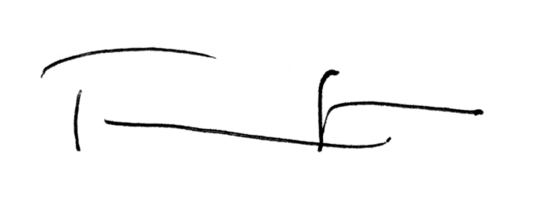Terrie Klinger |  | Date:  20 Jan 2015
Title:
Director
Department/Organization:
School of Marine and Environmental Affairs
Phone:  206-685-2499 | Email:  tklinger@uw.edu
Additional Notes:
Please save this completed form as “Project Contact Name_Project Name” and email it to csfcoord@uw.edu. The email originating directly from the approving body will be considered a signature. Paper copies may be sent through campus mail to Attn: CSF Coordinator, Box 351248 or dropped off to the CSF Office at Gerberding Hall, Room B-40 and must include an original signature of the approving body.

