Acceptance of Administrative Responsibility Form (AARF)
Project Title: Evaluating Campus Bird Building Collisions: A Critical Sustainable Design, Biodiversity, and Conservation Issue
Organizational (ORG) Code: Pending Approval
Grant Total: $107,001.60
Primary Contact: Judy Bowes (jbowes2@uw.edu)
Budget # (CSF-inputted):
By signing this form, I certify that I am the administrator (or equivalent) for my campus unit, in charge of expense, human resources, and other financial transactions and I agree to the following:
- To be responsible for any hiring actions and/or purchases associated with this project.
- To financially track this project in a “16-“ (ASUW) budget created by the CSF under the host departments the Financial Organization Code (OrgCode), and complete monthly BAR reconciliation.
Furthermore, I acknowledge the following:
- Overages: Any and all overages are the responsibility of the project / host department.
- Leftover Funds: Any unspent balance is to be returned to the CSF to go toward other projects. Exceptions can be made at the discretion of the CSF.
- Scope Changes: The CSF should be informed in advance of any changes in scope exceeding 10% of the total budget.
Notes (if applicable):
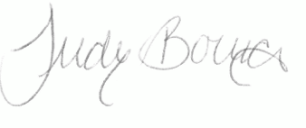  Project Lead Name/Signature: |  | Date:  04/21/22
Administrator Name/Signature: Alex Anderson  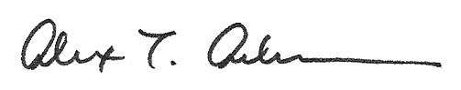 |  | Date:  4/21/22
Title:  Director, PhD in the Built Environment | Department/Organization:  College of Built Environments
Phone:  206-616-1261 | Email:  ata@uw.edu
Please save this completed form as “Project Contact Name_Project Name” and email it to csfcoord@uw.edu. The email originating directly from the approving body will be considered a signature.

