Project Approval Form (PAF)
Project Title: | Biodegradable Pots
Primary Contact: | Kaitlin Tighe

By signing this form, I confirm that the project lead(s) has/have discussed this project with me, and that I (please check all that apply)
X approve the stated project to be conducted on the University of Washington-Seattle campus
(this approval can only be given by campus units or by individuals on behalf of campus units)
(REQUIRED).
□ agree to be a part of the project team.
□ will provide support to the project by being a partnering organization, department or individual.
□ am the administrator for my campus unit and agree to for the financial and human resources
Transactions associated with this project.
□ agree to take over the operational costs of this project following completion.

Other notes (if applicable):

Name/Signature:  John Kelly/ 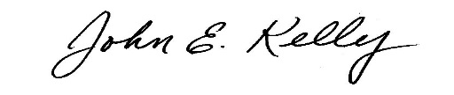 |  | Date:  5/1/17
Title:
Program Operations Specialist
Department/Organization:
Environmental Health & Safety
Phone:  206-616-3722 | Email:  jek@uw.edu
Additional Notes: I am approving this project to move forward from the conceptual idea outlined in the letter of intent to design. To approve a more formal design in the future, I will need to understand the process well enough to identify potential health & safety risks & how they will be resolved.

Please save this completed form as “Project Contact Name_Project Name” and email it to csfcoord@uw.edu. The email originating directly from the approving body will be considered a signature. Paper copies may be sent through campus mail to Attn: CSF Coordinator, Box 351248 or dropped off to the CSF Office at Gerberding Hall, Room B-40 and must include an original signature of the approving body.

