Date: 2nd May 2023
Time: 6 - 7:30pm
Attendees: Neha, Sohara, Tava, Tatiana, Esha, Emmy, Nat & Lauren

Proceedings
- Presentation from Ken Yocom and Polly on cross cultural collaboration at the Burke Meadow: Maintenance, Management and Education for a Living Exhibit.
- Shared management between the project team and academic + professional partners. Continuing to partner with Oxbow for new planting and replanting
- Engaged with UW food knowledge family
- They have been invited to contribute to the journal of ecological restoration and have been featured on the Seattle times
- Partnered with two elders from the Yakima nation to build fences for rabbits
- The current proposal is to support an additional year of support for student collaborators and researchers, materials and event support. Received support from Burke Museum and Urban and UW. Total ask from CSF: $28,740, mainly as a transition into the mellon grant for next year. The budget is for graduate student/partial employment, supplies, materials and events.

Screenshots from their slides for reference/records:
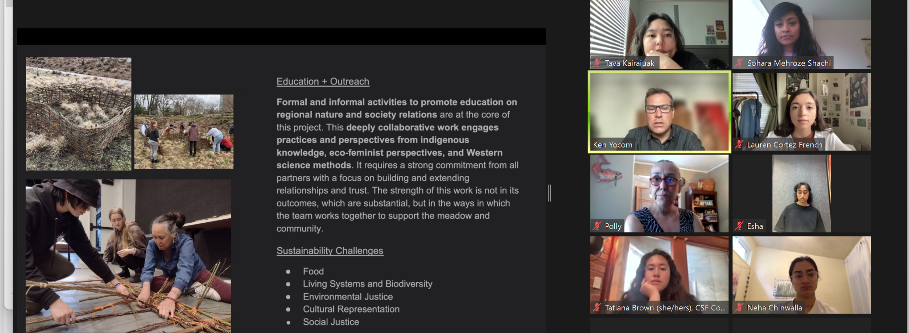
- Project presentation by Dan Dimitrov (PhD student) on Energy, Information, and the New Work of Building Operations in the Digital Age
- Research goal is primarily to aid in UW’s standardization and carbon emission reduction efforts with regards to utilization of IOT in facility management work and address knowledge gaps in integrating new tech in existing systems
- The research team comprises of student project lead Daniel Dimitrov Faculty PI Carrie Sturts Dossick and research assistant (potentially an MS student)
- Plan to collaborate with UW Facility, Maintenance and Management unit, business innovation and tech unit of UW FM. Collab with Digital Twin
- The methodology involves conducting three cases:
1. Campus wide energy meter monitoring program
2. Automation window actuators + Founders lighting control occupancy sensors
3. Automatic window tinting tech in health sciences building
- They will conduct 10-15 expert interviews
- Starts with a feasibility study, around June. Plan to conclude by September.
- Total ask is $19832 (see screenshot for budget details). They have not had conversations with facility maintenance/other parties for funding.
- Open to involving more students

Screenshots of slides provided below as reference:
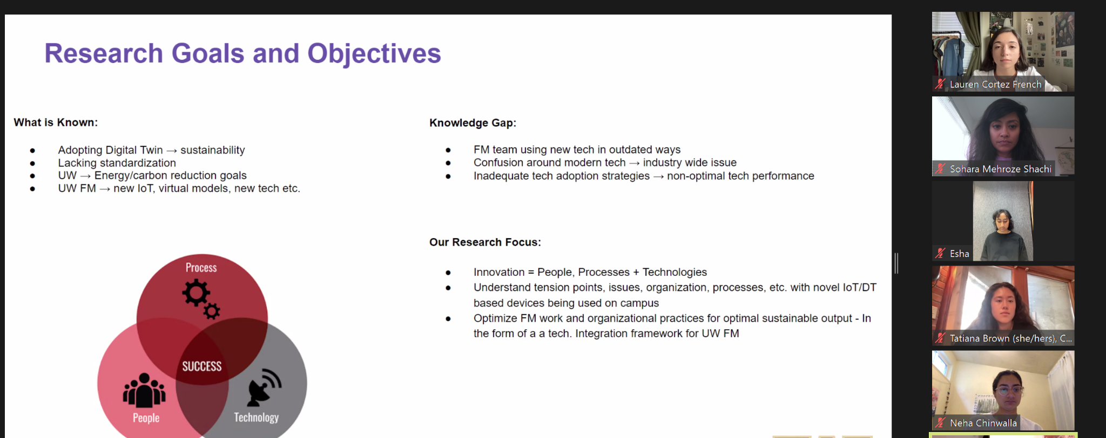
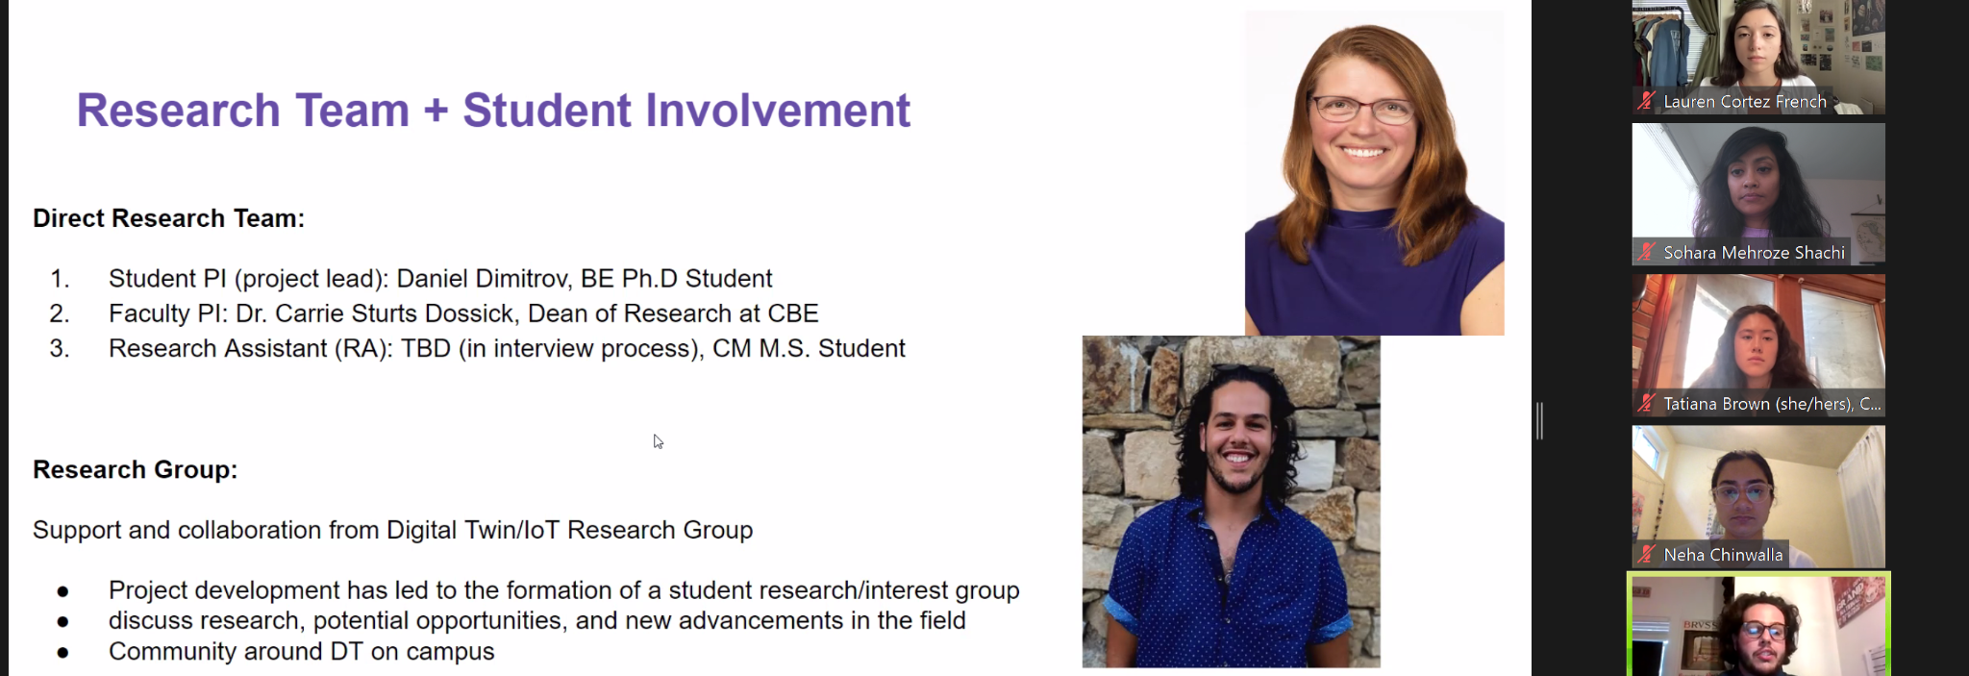
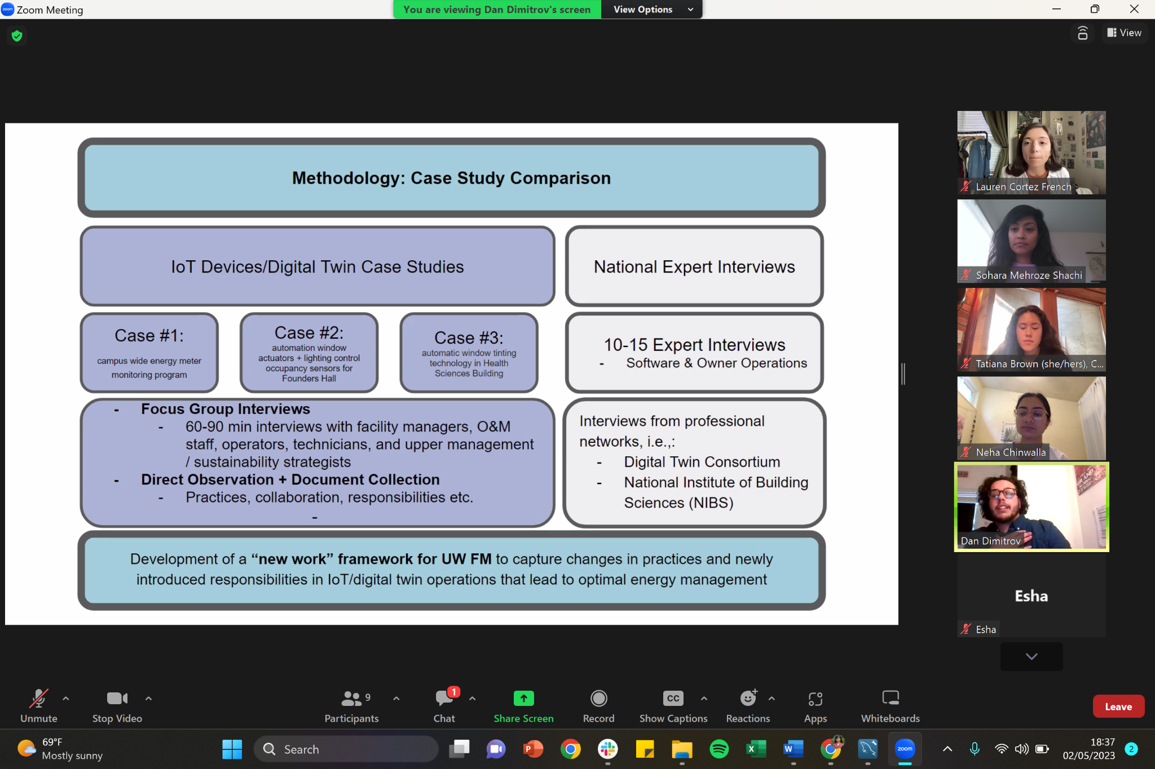
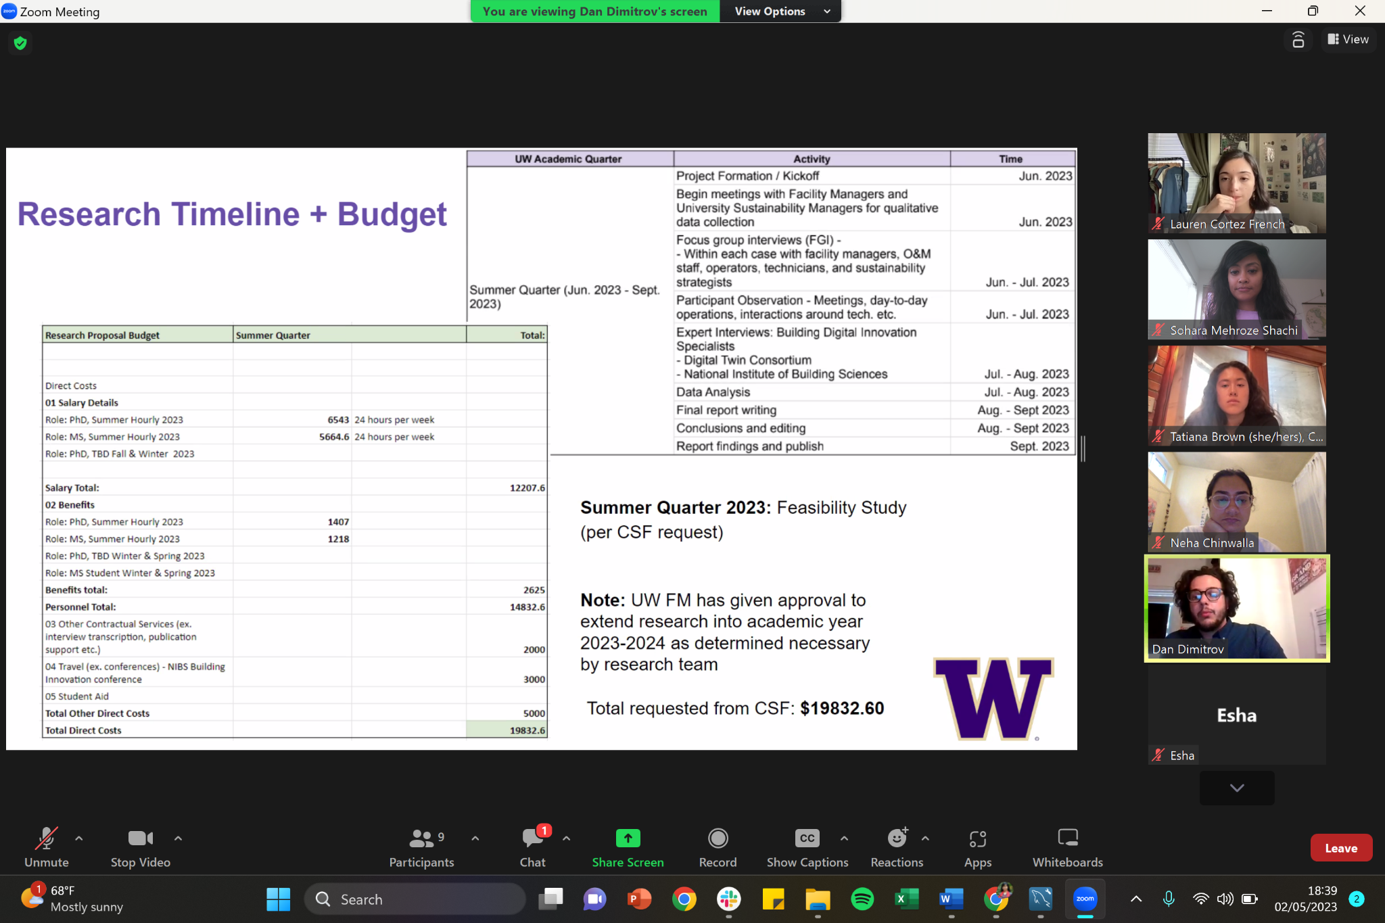
- Project presentation by Toby Gallant: ADA Approved Trail at the UW Farm: Promoting the Intersection of Environmental Justice and Sustainability
Proposal shared during the zoom call: https://docs.google.com/document/d/1YiccffIVMABD5uBFASUlAzZkKfEtXLDBUp
The pitch in a nutshell: Farm trails and pathways do not currently provide access for people with disabilities. If there were ADA pathways then people in wheelchairs could learn about urban farming and related issues, recreate, and help plant, harvest and consume the produce grown on campus. Only the farm site at the Center for Urban Horticulture offers the potential for ADA approved pathways, due to gentle slope, proximity to restrooms, handicapped parking and amenities. The UW Farm and students would like to help provide more access to the farm space, but lack funds to do so; hence they are seeking CSF’s support.

The screenshot below is of the model showing the children’s garden, resiliency tunnel, heritage orchard, native garden, world cultural kitchen etc.
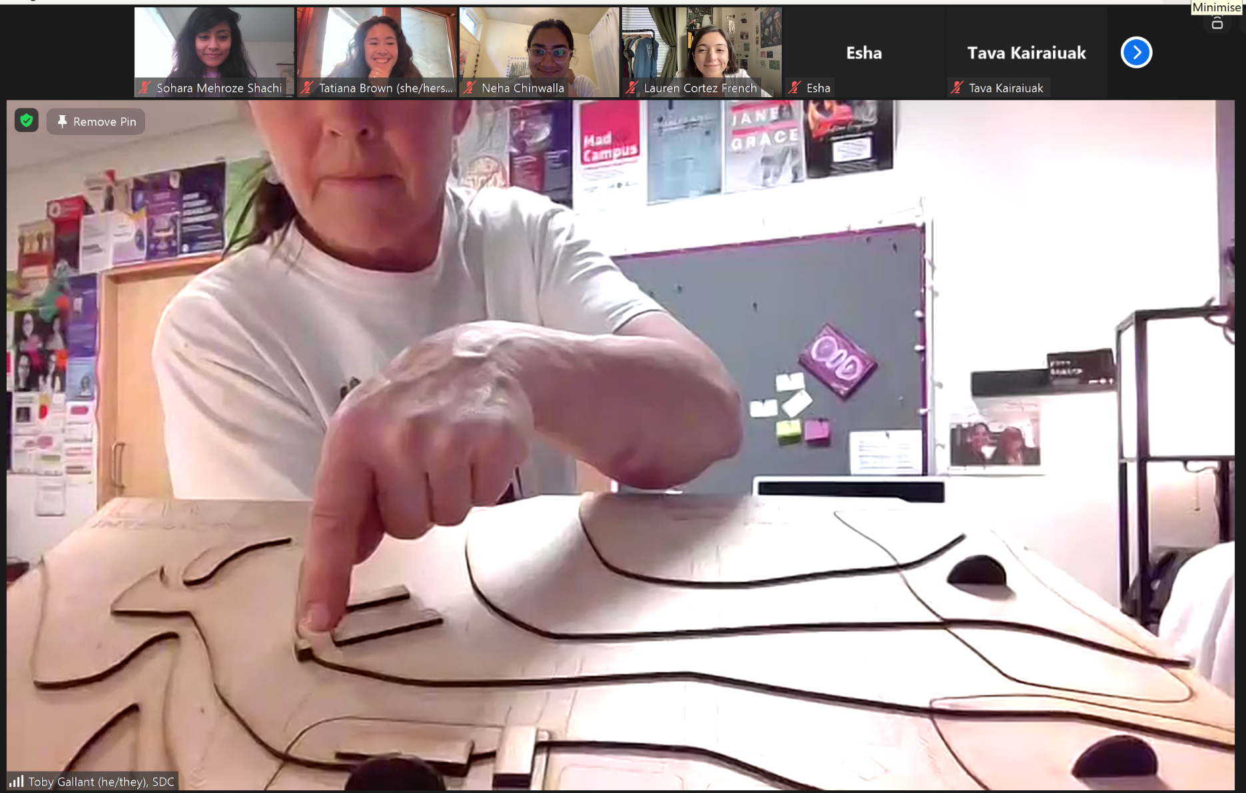
The world cultural kitchen (third phase of the project) is being built now.
Major costs are materials and labor. Total ask from CSF is $17,220.

Screenshot below shows the location of the project:
- Project presentation by Kathryn R. Merlino and Matt Newman: Sustainable (net zero) Stormwater Feasibility @ the ASUW Shell House
- Fun fact: the shellhouse was built as a hangar for naval aviators during WWII. It is also an important indigenous property and home for Olympic crew champions. The objective is to preserve the site in an ecologically sustainable manner.
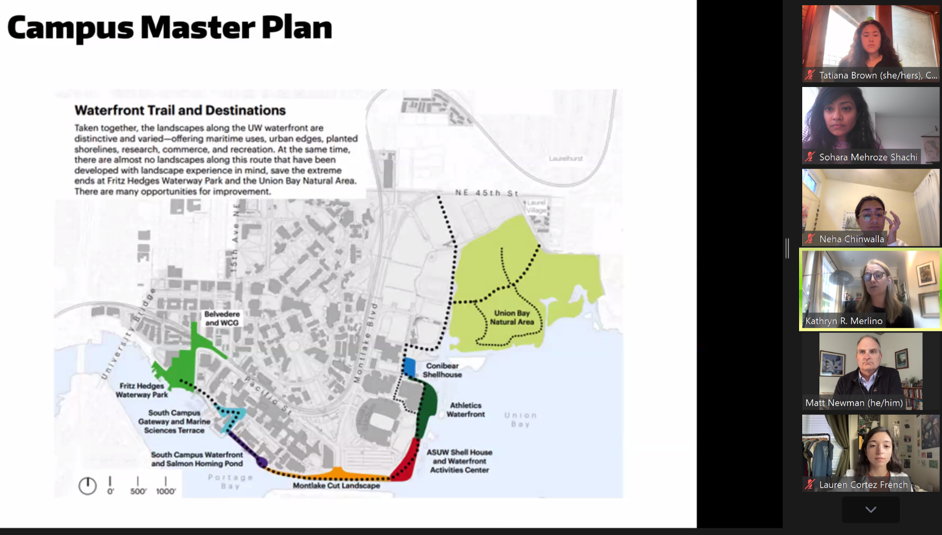
- The pitch: The current stormwater infrastructure is unknown & does not take care of the water on site. All the water falls into very old basins, is treated imperfectly and is routed directly into lake washington, bringing in toxins, impurities and warm water, which is bad for salmon. The proposal is to treat the water onsite using indigenous plants that are bio remediators and construct natural wetlands. They aim to create a sustainability demonstration project.
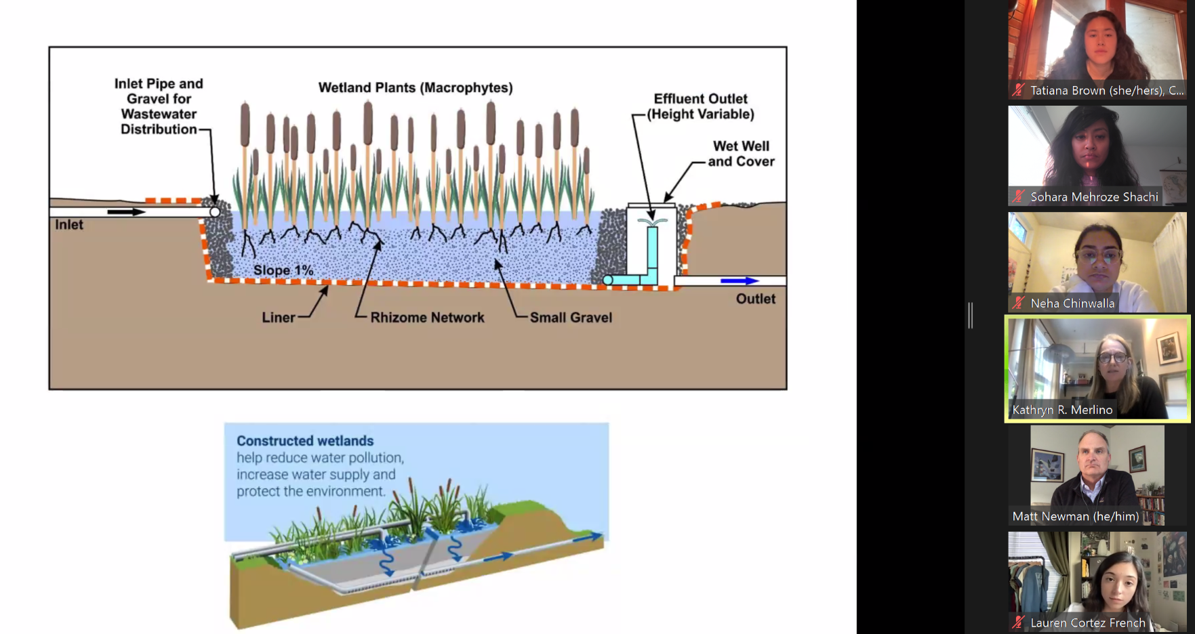
- Students would be involved in landscape designing & identifying the right plants.
- Professor Merlino will share a copy of the presentation with CSF.
- Total Request from CSF is 31,959.00
- Voting outcome:
- Budget amendment for TSA night market and Keraton has passed.
- Full proposal for Burke meadows,ADA, Shellhouse and energy buildings passed.

- Upcoming events:
- Intellectual House Symposium on Indigenous Food Systems (Friday and Saturday)
- Keraton (Saturday)
- UAW 4121 Social Justice Conference (Saturday and Sunday → students in the union)

