Campus Sustainability Fund
Committee Meeting Agenda

Tuesday, January 24, 2023
6:00-7:30 pm PDT LOCATION: IN PERSON
Gerberding Conference Room B42 (code: 3696)

Join Zoom Meeting (2022-2023)
https://washington.zoom.us/j/5100844374

Agenda
Time | Item | Facilitator
6:00-6:15 | Check-in & Ice Breaker: if you could be an animal, what would you be? What is the most underrated vegetable? | Neha
6:15-6:40 | Housekeeping:  - Student Activities Fund Presentation Update  - Budget (Submitted)  - Updates on meeting with appointed bodies | Tatiana, Kyle
6:40-7:30 | Review mini-grants:  - WashPIRG Beyond Plastics Carnival  - Polynesian Day 2023  VOTE! | Neha/Gulsima
Stay tuned… next time 🙂 | Discussion!  - What has been your experience as a student with sustainability at UW?  - What is missing from this experience? How can we help fill this gap?  - What does environmentalism mean to you? What makes someone an environmentalist?  - How can we foster connections/collaborations across sustainability groups (including cultural groups)? | Neha
7:30 | Wrap Up | Neha

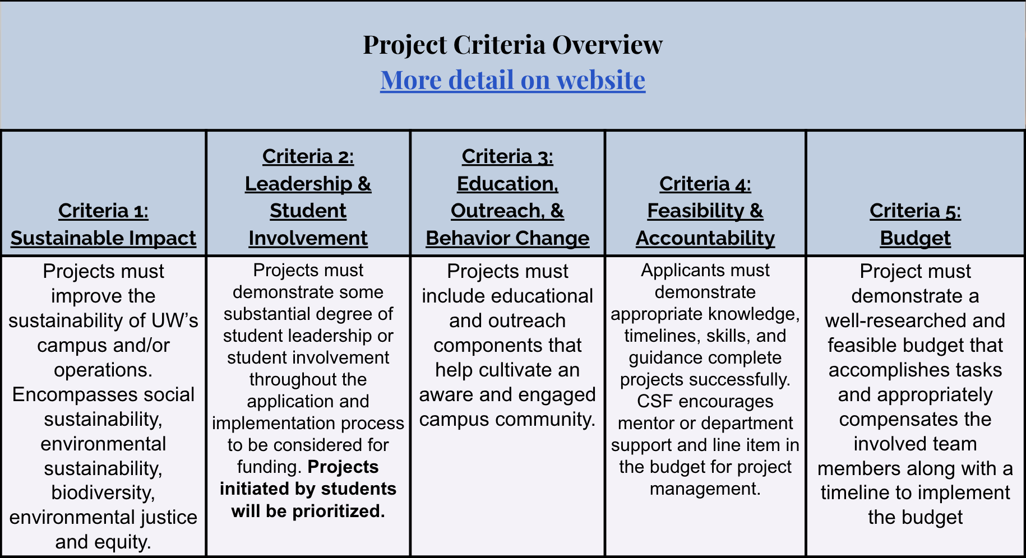

https://csf.uw.edu/how-apply/funding-guidelines

Non Allowable Uses:
- Funding cannot be used for time and labor expended by UW faculty working unless it is outside the scope of regular faculty duties.
- Funding cannot be used for the purchase of gift cards or other forms of compensation to research subjects. While we encourage compensating research subjects for their time, this must come from another funding source.
- In general, funds cannot be used for food, drinks, or salable merchandise as part of project budgets. Some exceptions may be granted.
- Line-item requests for travel funding are not encouraged, but will be considered on a case by case basis.
- Funds shall not be used for research projects unless such projects include an actionable component.

Some things for us to discuss:
- The program and position outcomes → feedback, thoughts, ideas
- Balance of adequate staffing
- Professional development opportunities

CSF Bylaws + Protocols
Committee Bylaws
Robert’s Rules of Order
Liberating Structures
CSF Committee Google Drive
2022-2023 Committee Documents

How to evaluate projects
CSF Project Criteria
Reference Sheets
Evaluation Rubric Example (go to Rubric Template tab)

Current projects + timeline
Workday Orientation - https://tinyurl.com/csf-workday
2022-2023 Proposal Deadlines & Timeline
CSF Resource Guide

CSF Committee Attendees: Neha, Esha, Lauren, Emmy, Sohara, Tava
CSF Staff Attendees: Tatiana, Kyle, Gulsima, Kort
UWS Attendees: Christoph

