Campus Sustainability Fund
Committee Meeting Agenda

Tuesday, April 4, 2023
6:00-7:30 pm PDT LOCATION: ZOOM

Join Zoom Meeting (2022-2023)
https://washington.zoom.us/j/5100844374
washington.zoom.us…
Agenda
Time | Item | Facilitator
6:00-6:20 | Check in + icebreaker | Neha
6:20-6:40 | Housekeeping  - Seed Grant Applications are LIVE, open until April 30 → spread the word  - Decision on Bricolage Literary Journal  - 4/6: Two Decarbonization Meetings, with Dave 12p-1p & students only 2:30-3:30p  - 4/7: Husky Sustainability Award Nominations due THIS Friday  - 4/8: First Nations powwow THIS Saturday (10a-4p at Alaska Air Arena, HecEd)  - 4/14: Earth Day @ the ECC NEXT Friday (11a-1:30p) → seeking volunteers  - 4/15: The Women’s Center “Mother Earth and Indigenous Lands” NEXT Saturday (11:30a-2:30p) | Tatiana, Neha
6:40-7:00 | Mini grant review:  - Canoe Family at UW – IT PASSES!  - Engineers Without Borders Project Mobility – IT PASSES! | Neha, Gulsima
7:00-7:25 | Discussion: Potential bylaw change  - Shifting some funding to internal project/program ideas  - Q Center Menstruation Station as pilot | Kyle, Tatiana
7:25-7:30 | Wrap up  - Before next meeting  - Reflect on your goals for the year (miro board)  - Anything else you want to work on/achieve (professional development, personal, with the committee, etc.) | Neha

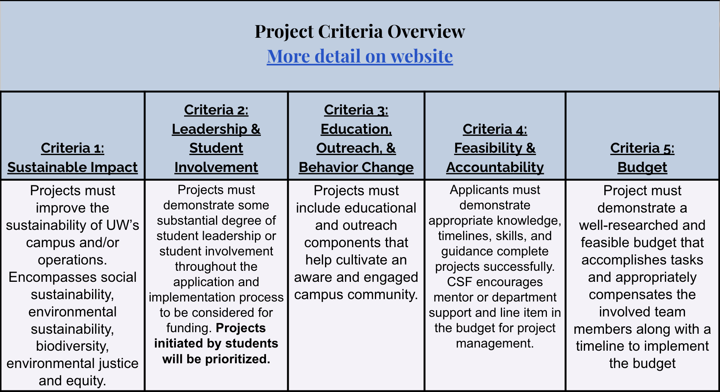

https://csf.uw.edu/how-apply/funding-guidelines

Non Allowable Uses:
- Funding cannot be used for time and labor expended by UW faculty working unless it is outside the scope of regular faculty duties.
- Funding cannot be used for the purchase of gift cards or other forms of compensation to research subjects. While we encourage compensating research subjects for their time, this must come from another funding source.
- In general, funds cannot be used for food, drinks, or salable merchandise as part of project budgets. Some exceptions may be granted.
- Line-item requests for travel funding are not encouraged, but will be considered on a case by case basis.
- Funds shall not be used for research projects unless such projects include an actionable component.

CSF Bylaws + Protocols
Committee Bylaws
Robert’s Rules of Order
Liberating Structures
CSF Committee Google Drive
2022-2023 Committee Documents

How to evaluate projects
CSF Project Criteria
Reference Sheets
Evaluation Rubric Example (go to Rubric Template tab)

Current projects + timeline
Workday Orientation - https://tinyurl.com/csf-workday
2022-2023 Proposal Deadlines & Timeline
CSF Resource Guide

CSF Committee Attendees: Neha, Lauren, Emmy, Sohara, Tava, Nat
CSF Staff Attendees: Tatiana, Kyle, Gulsima
UWS Attendees: —

