Agenda
Time | Item | Facilitator
6:00-6:10 | Mini Grant  - KERATON (Event Date: May 6) $5000  Budget Amendment  - 2023 TSA Night Market Sustainable Program (Event Date: may 13) $1000 | Neha & Tatiana
6:10-6:30 | Project presentation: Cross-Cultural Collaboration at the Burke Meadow: Maintenance, Management and Education for a Living Exhibit (  Q&A  LOI  Full Proposal | Neha / project presenters
6:30-6:50 | Project presentation: Energy, Information, and the New Work of Building Operations in the Digital Age  Q&A  LOI  Full Proposal | Neha / project presenters
6:50-7:10 | Project presentation: ADA Approved Trail at the UW Farm: Promoting the Intersection of Environmental Justice and Sustainability  Q&A  LOI  Full Proposal | Neha / project presenters
7:10-7:30 | Project presentation: Sustainable Stormwater Feasibility @ the ASUW Shell House  Q&A  LOI  Full Proposal | Neha / project presenters
7:30-7:35 | Vote & Adjourn  Events:  - Intellectual House Symposium on Indigenous Food Systems (Friday and Saturday)  - Keraton (Saturday)  - UAW 4121 Social Justice Conference (Saturday and Sunday → students in the union) | Neha

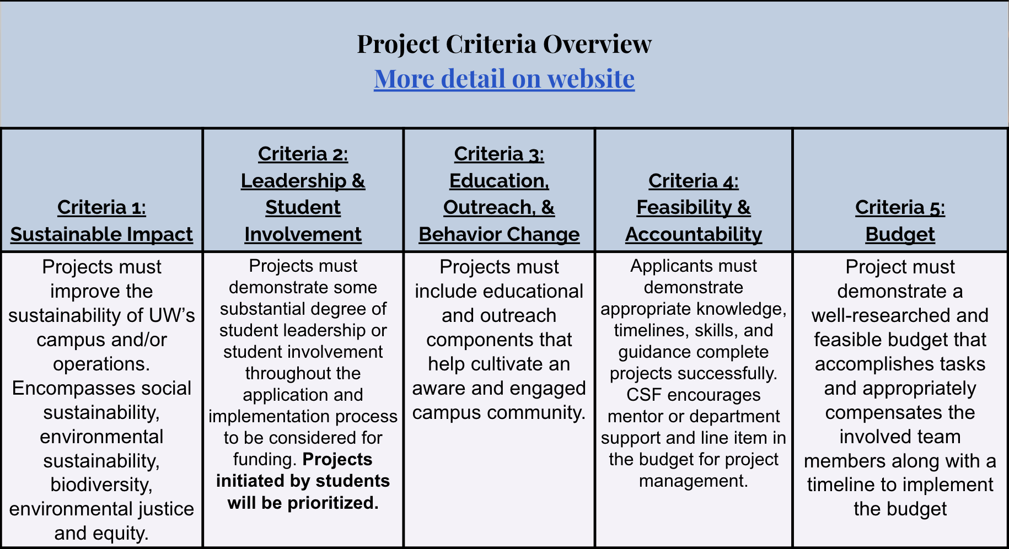

https://csf.uw.edu/how-apply/funding-guidelines

Non Allowable Uses:
- Funding cannot be used for time and labor expended by UW faculty working unless it is outside the scope of regular faculty duties.
- Funding cannot be used for the purchase of gift cards or other forms of compensation to research subjects. While we encourage compensating research subjects for their time, this must come from another funding source.
- In general, funds cannot be used for food, drinks, or salable merchandise as part of project budgets. Some exceptions may be granted.
- Line-item requests for travel funding are not encouraged, but will be considered on a case by case basis.
- Funds shall not be used for research projects unless such projects include an actionable component.

CSF Bylaws + Protocols
Committee Bylaws
Robert’s Rules of Order
Liberating Structures
CSF Committee Google Drive
2022-2023 Committee Documents

How to evaluate projects
CSF Project Criteria
Reference Sheets
Evaluation Rubric Example (go to Rubric Template tab)

Current projects + timeline
Workday Orientation - https://tinyurl.com/csf-workday
2022-2023 Proposal Deadlines & Timeline
CSF Resource Guide

CSF Committee Attendees: Neha, Lauren, Emmy, Sohara, Tava, Nat
CSF Staff Attendees:
UWS Attendees: —

Budget Amendments for NEXT meeting
- Heron Haven
- Engineers Without Borders Sol Stations (can push to next meeting depending on time)

