Agenda
Time | Item | Facilitator
6:00-6:05 | Housekeeping/Updates | Tatiana
Starting at 6:05 | Budget Amendments  - Heron Haven ($16,016.69)  - Engineers Without Borders Sol Stations (ability to change what the money is allocated to)  Mini Grants  - Sustaining for Us, $4,000  - LOI  - Budget  - UW Farm Wapato Pond, $5,000  - LOI  - Budget | Neha
After voting | Hang out  - Are you planning to stay on the committee next year?  - Summer plans?  - Any professional goals we can support?  - Are there any professors you think would be good ex-officio members of the committee? | Everyone

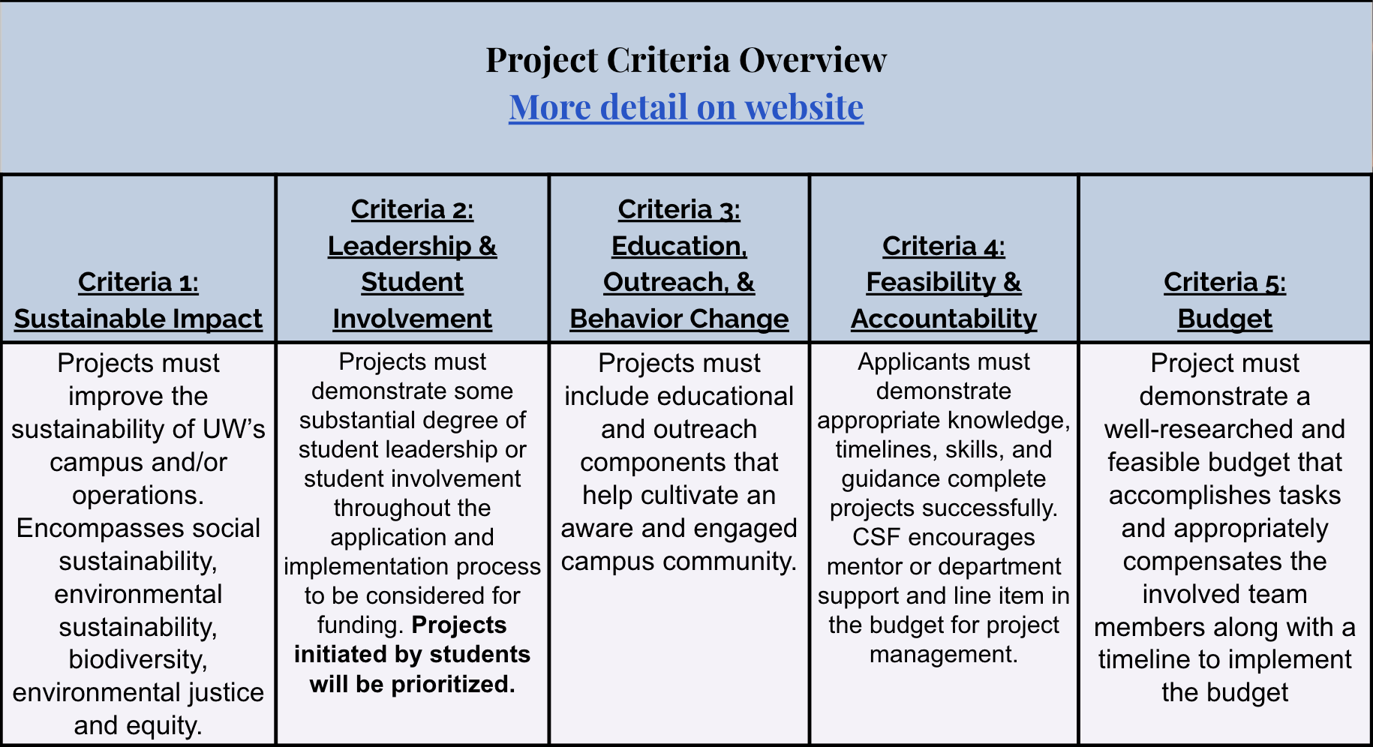

https://csf.uw.edu/how-apply/funding-guidelines

Non Allowable Uses:
- Funding cannot be used for time and labor expended by UW faculty working unless it is outside the scope of regular faculty duties.
- Funding cannot be used for the purchase of gift cards or other forms of compensation to research subjects. While we encourage compensating research subjects for their time, this must come from another funding source.
- In general, funds cannot be used for food, drinks, or salable merchandise as part of project budgets. Some exceptions may be granted.
- Line-item requests for travel funding are not encouraged, but will be considered on a case by case basis.
- Funds shall not be used for research projects unless such projects include an actionable component.

CSF Bylaws + Protocols
Committee Bylaws
Robert’s Rules of Order
Liberating Structures
CSF Committee Google Drive
2022-2023 Committee Documents

How to evaluate projects
CSF Project Criteria
Reference Sheets
Evaluation Rubric Example (go to Rubric Template tab)

Current projects + timeline
Workday Orientation - https://tinyurl.com/csf-workday
2022-2023 Proposal Deadlines & Timeline
CSF Resource Guide

CSF Committee Attendees: Neha, Lauren, Emmy, Sohara, Tava, Nat
CSF Staff Attendees:
UWS Attendees: —

